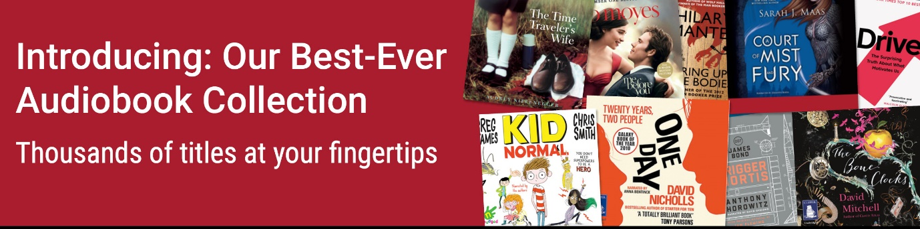[insert your library logo]

|  |  |  |
| --- | --- | --- |
| |  |  | | --- | --- | | Dear library borrower,  We’re thrilled to announce the dramatic expansion of our RBdigital audiobook collection. With thousands of titles, there’s something for everyone—from classics to bestselling new titles, debut authors to major literary prize winners, children’s literature to business books, and more.  Plus, over 20,000 of these audiobook titles are “unlimited access” so you can enjoy immediate access without any holds or delays.  With thousands of titles instantly available you’ll always have something new and interesting to listen to.  Visit **[insert library URL]** or the RBdigital app to start listening today! |  | |
|  |
| |  |  |  | | --- | --- | --- | |  | https://cdn2.hubspot.net/hubfs/3812525/January-LY9676-Best-Ever%20Audiobooks/RBd-Toolkit_28000titles.jpg  20,000+ Titles  More than 20,000 titles are available for listening without holds or delays. You’ll always have something new and interesting to listen to! |  | |
|  |
| |  |  |  | | --- | --- | --- | |  | https://cdn2.hubspot.net/hubfs/3812525/January-LY9676-Best-Ever%20Audiobooks/RBdToolkit_SomethingEveryone.jpg  Something for Everyone  RBdigital has everything from *The Book of Dust* by Philip Pullman to *Me Before You* by Jojo Moyes and *Bring up the Bodies* by Hilary Mantel , in addition to non-fiction, self-help, children’s titles, and more! |  | |
|  |
| |  |  |  | | --- | --- | --- | |  | https://cdn2.hubspot.net/hubfs/3812525/January-LY9676-Best-Ever%20Audiobooks/RBd-Toolkit-FewerHolds.jpg  Fewer Holds  This expanded collection offers a record number of always-available titles,  so you spend less time waiting on holds. |  | |
|  |
| |  |  |  | | --- | --- | --- | |  | https://cdn2.hubspot.net/hubfs/3812525/January-LY9676-Best-Ever%20Audiobooks/RBd-Toolkit_ListenAnywhere.jpg  Listen from Anywhere  With RBdigital, you can listen to audiobooks at home or on the go  from your computer, tablet, or smartphone. |  | |
|  |
| |  |  |  | | --- | --- | --- | |  | **Getting Started:  How to Register and Access RBdigital Unlimited Audiobooks**  Get the RBdigital app to access your audiobooks on the go!  If you haven’t already, register for an RBdigital app account at **[insert library RBdigital URL]**. For more information, refer to the first two steps on page one of the Account Setup [**user guide**](https://www.keepandshare.com/doc/8216469/rbdigital-all-in-one-desktop-registration-and-app-log-in-user-guide?da=y).  Once you’re registered, you can access RBunlimited Audiobooks from your mobile device using the following steps:   1. Download the RBdigital app in the app store. **[https://cdn2.hubspot.net/hubfs/3812525/January-LY9676-Best-Ever%20Audiobooks/RBd-Toolkit-Appstore-Apple.jpg](https://itunes.apple.com/us/app/rbdigital/id515311743?mt=8)** **[https://cdn2.hubspot.net/hubfs/3812525/January-LY9676-Best-Ever%20Audiobooks/RBd-Toolkit-Appstore-Google.jpg](https://play.google.com/store/apps/details?id=com.ocd&hl=en_US)** **[https://cdn2.hubspot.net/hubfs/3812525/January-LY9676-Best-Ever%20Audiobooks/RBd-Toolkit-Appstore-Amazon.jpg](https://www.amazon.com/Recorded-Books-RBdigital/dp/B009GLFOL4)** 2. Open the RBdigital app and follow the prompts to sign in to your account. 3. Open the menu and select BOOKS and then AUDIOBOOKS to browse audiobook titles. 4. Tap CHECKOUT and then PLAY to begin listening.   View the [**RBdigital user guide**](https://www.keepandshare.com/doc/8216469/rbdigital-all-in-one-desktop-registration-and-app-log-in-user-guide?da=y) for more detailed instructions on how to download and navigate the app, or email the [**RBdigital support team**](mailto:rbdigital@wfhowes.co.uk)with questions. |  | |