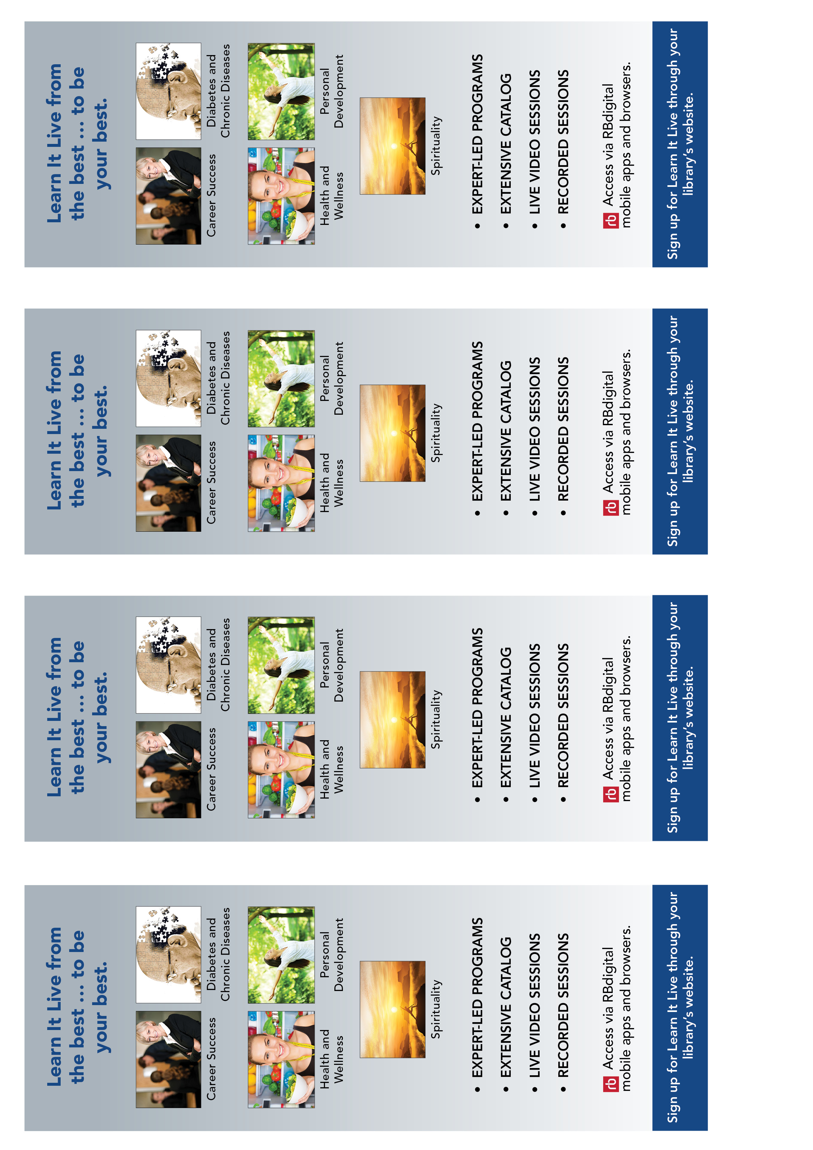

[insert library logo]

[insert library URL]

[insert library logo]

[insert library URL]

[insert library logo]

[insert library URL]

[insert library logo]

[insert library URL]