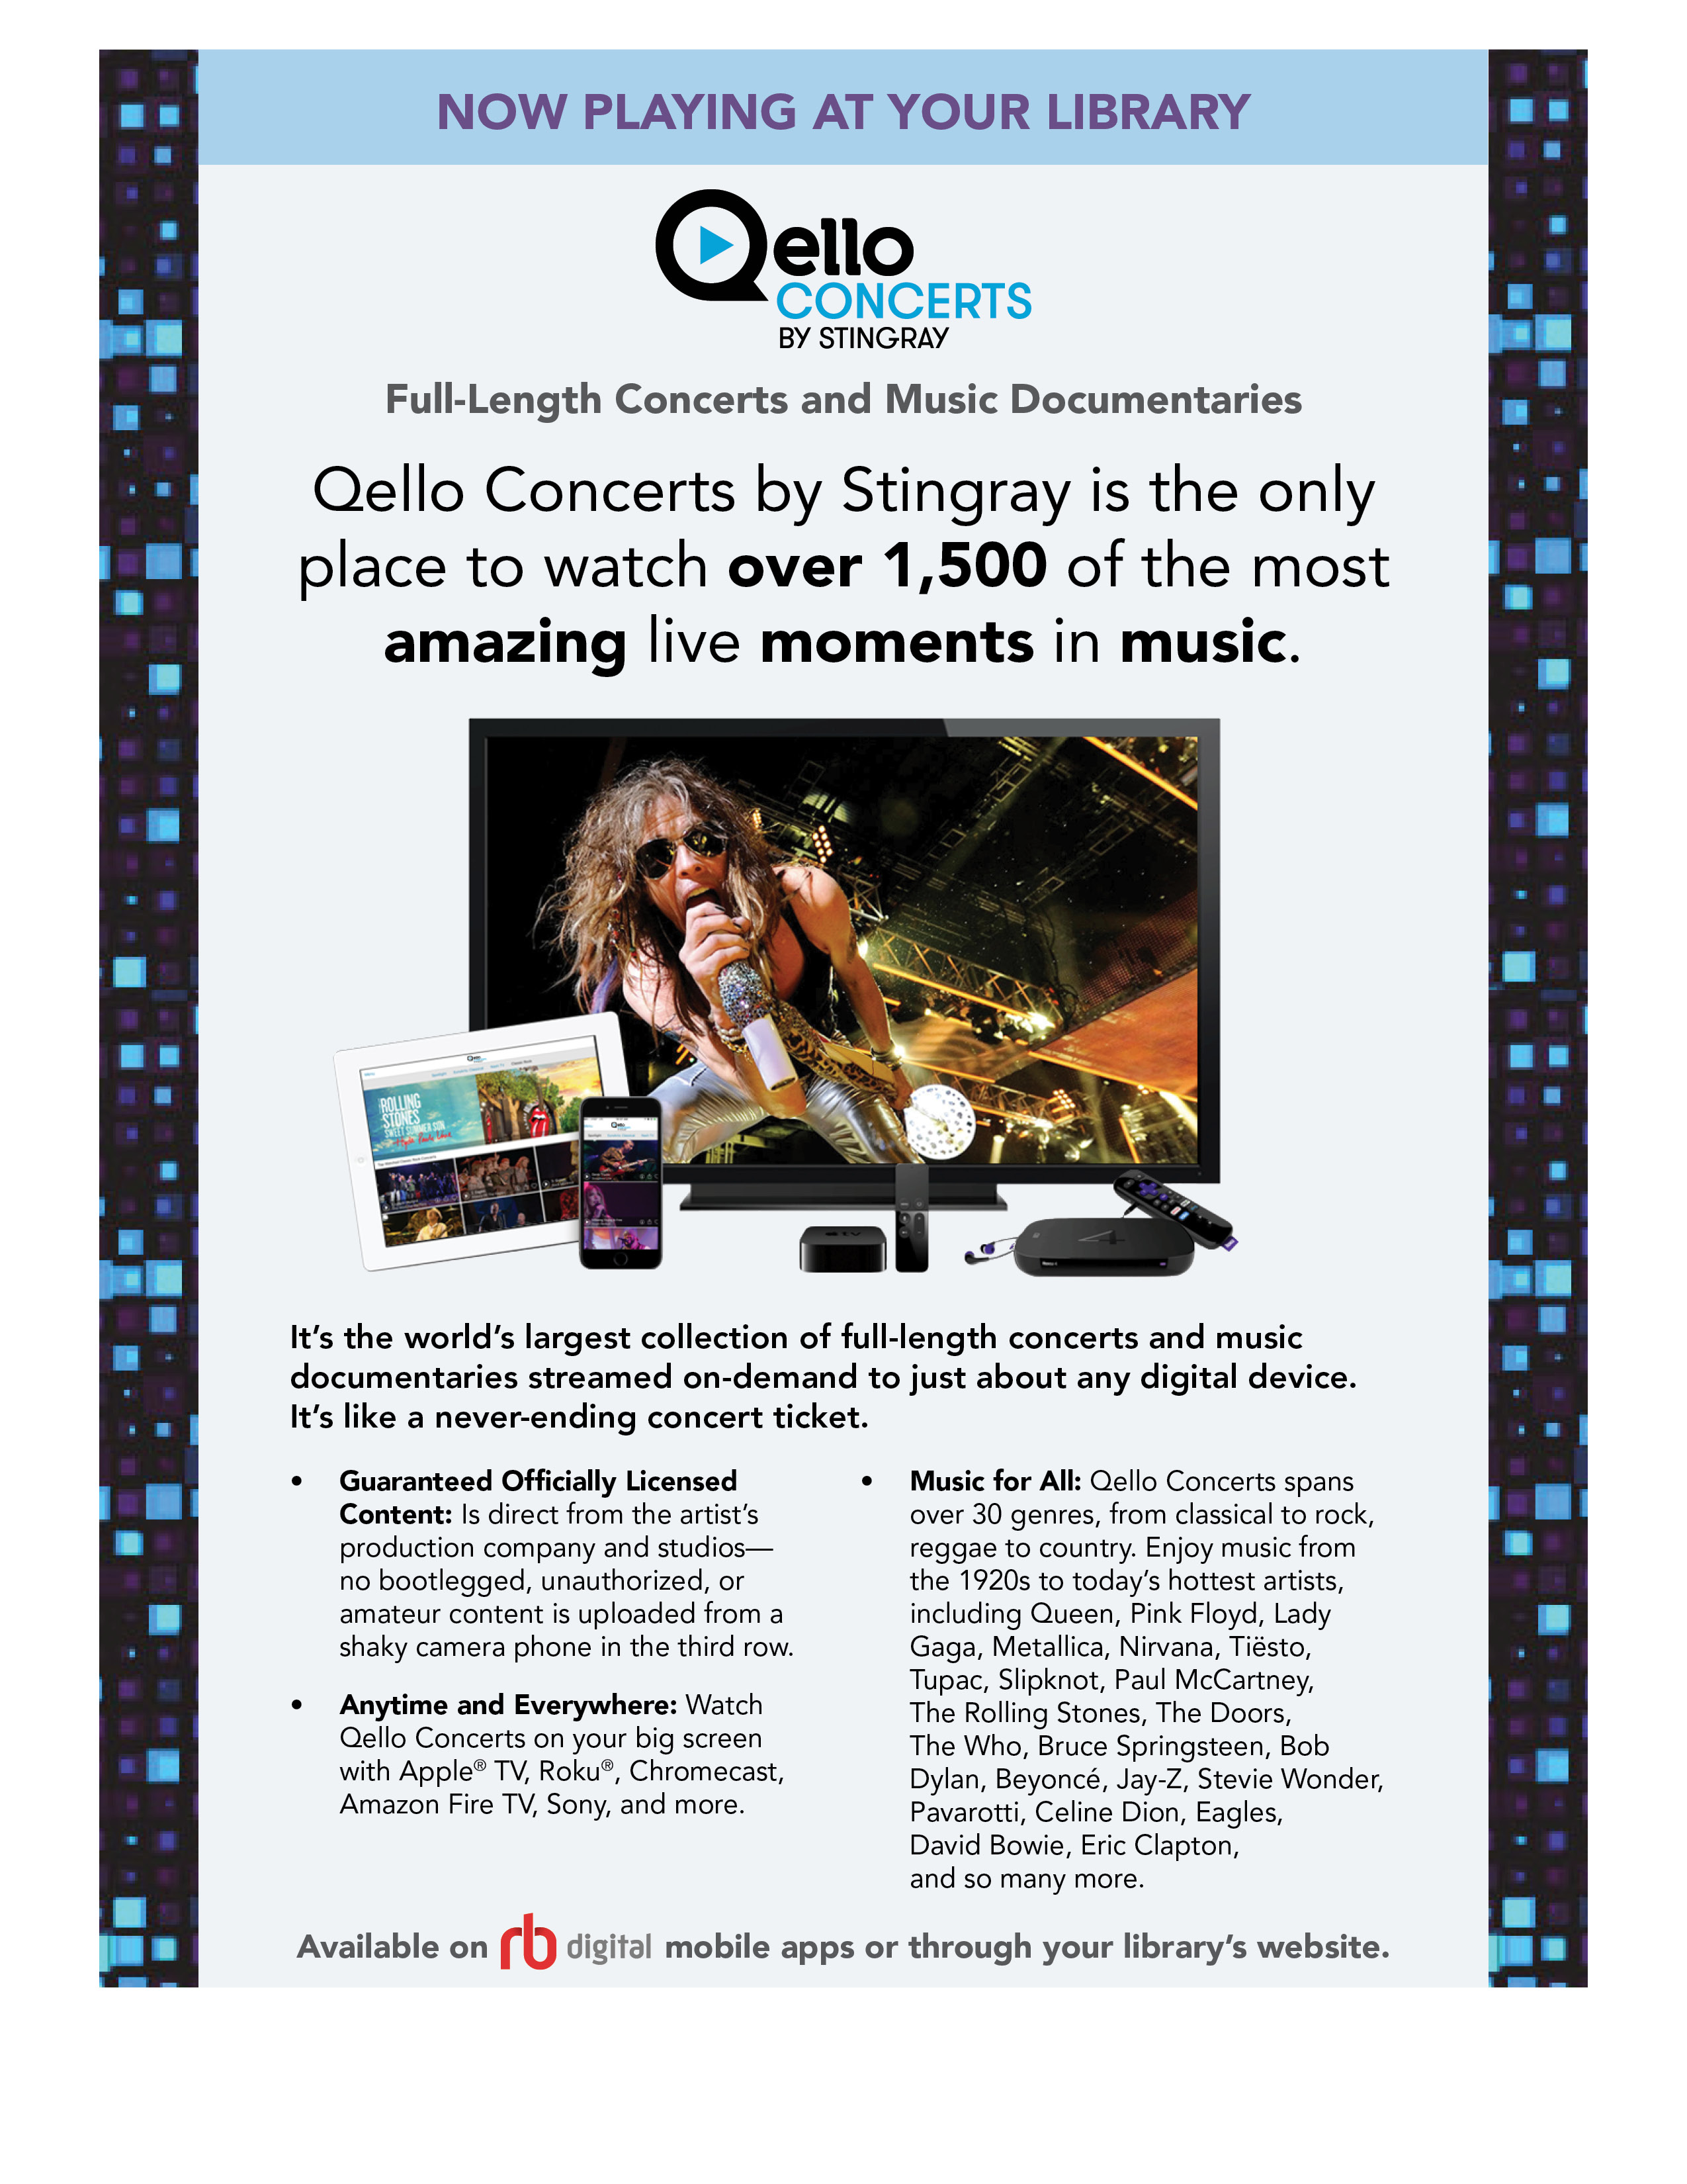

**[Replace with library logo] [Replace with library URL]**