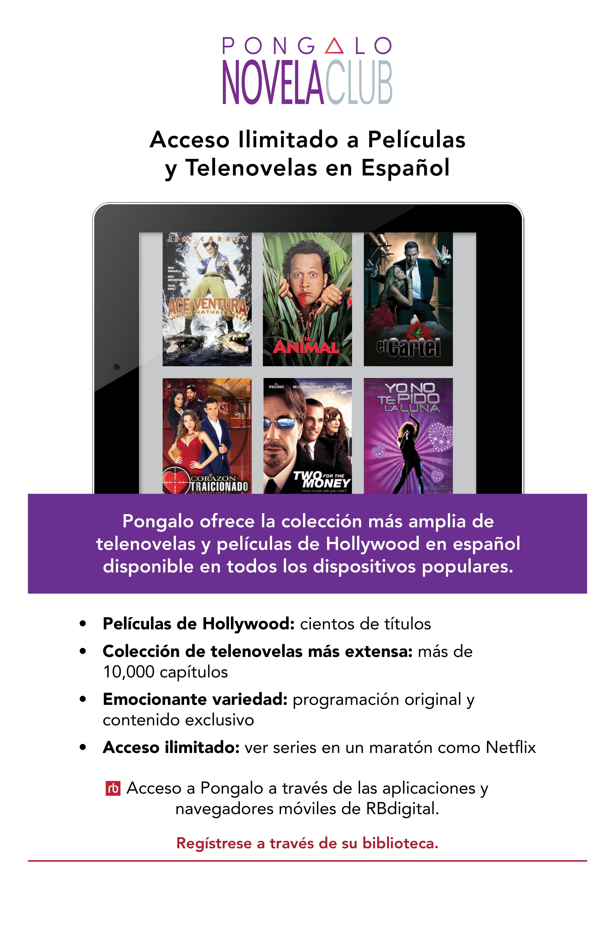­­­­­­­

[ Your Library Logo ]

www.YourLibraryURL.com