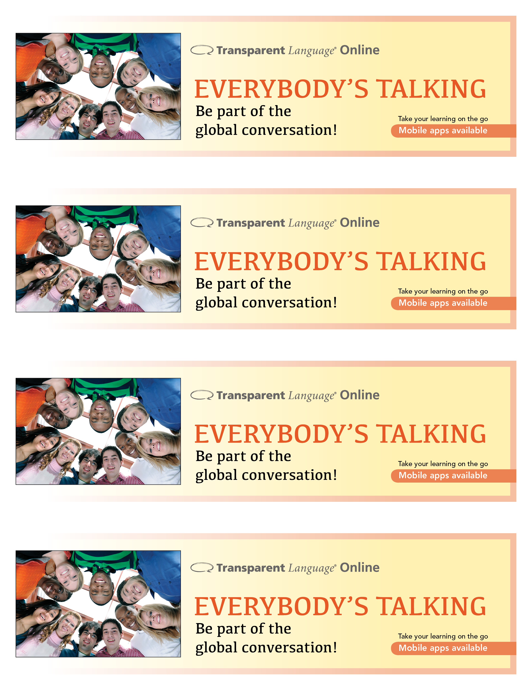

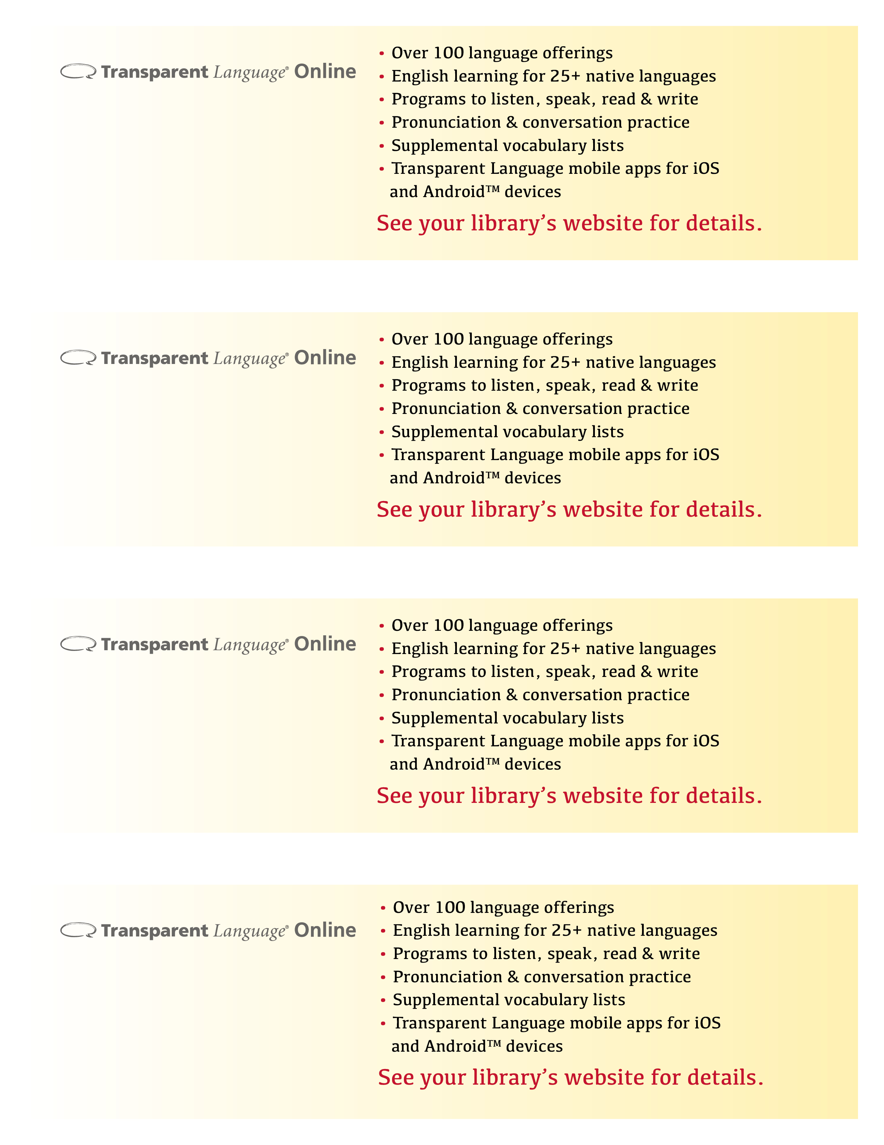

[Replace with library logo or URL]

[Replace with library logo or URL]

[Replace with library logo or URL]

[Replace with library logo or URL]