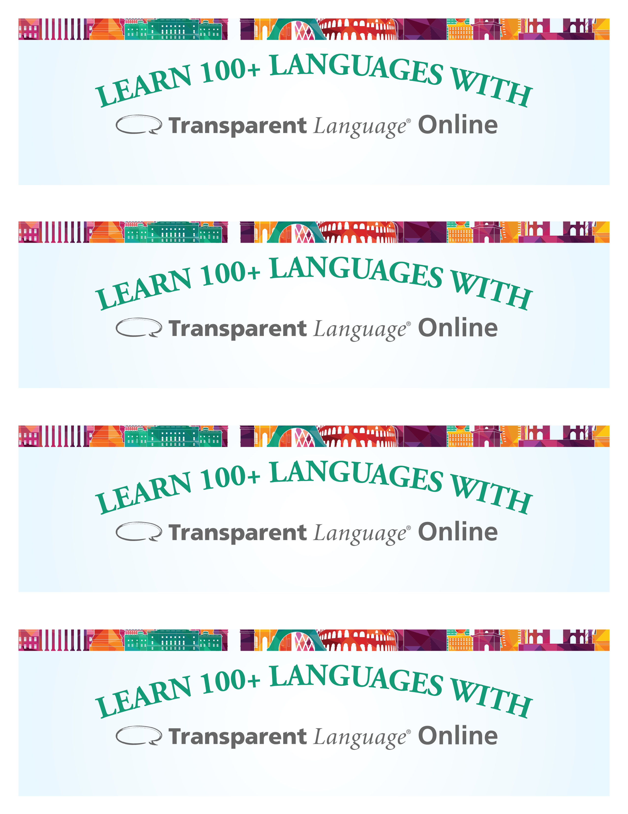

[Replace with library logo]

[Replace with library URL]

z

[Replace with library logo]

[Replace with library URL]

z

[Replace with library logo]

[Replace with library URL]

z

[Replace with library URL]

z

[Replace with library logo]